**Discussion Question: 100 Things**

Using the ***100 Things Every Designer Should Know About People*** reading assignment, select two (2) of the "things" you read about, include the number and title of the "thing" (i.e. #36 Time is Relative) and then do two embellishments, one embellishment and one visual example, or two visual examples.

1. **Embellish:** Tell us something that the reading did not tell us on that specific "thing" or embellish on what was presented. Be sure you are adding meaningful content to the conversation and not just making noise. Your addition can be a link to an article or you can write out your embellishment.
2. **Visual Example:** Provide us with a graphic example that is relevant to web design. This can be something you create or something you find. Again, be sure to add meaningful content to the conversation.

For my first embellishments, I decided to touch more on Topic 39: Culture Affects How People Think. Whether we realize it or not, we are significantly influenced by culture. Our worldviews, behaviors, how we process information, communicate, and so much more vary based on culture. A thumbs up may seem like an appropriate response in the United States, but using the gesture in places like the Middle East or Latin America would not send a good message since it has the same meaning as giving someone the middle finger in the US.

UI design should consider etiquette in other cultures, especially when wanting to appeal to a larger audience. Be wary of including slang or sayings that others can misinterpret. The okay sign can also be offensive, so don’t include an image like this one from Vecteezy’s on a webpage or application.



https://www.vecteezy.com/vector-art/36941590-woman-holding-smartphone-and-shows-ok-sign

The second topic in our book I chose to elaborate on is Topic 43: Expectations of Frequency Affect Attention. In our daily routines, we are used to encountering similar instances and moments with or without our conscious awareness. When we do not expect to see something, it can be easier to miss it without realizing it. It is easy to go through life without noticing something until it is pointed out. When that happens, then it becomes easier to spot it.

When thinking about UI, we should remember that if someone constantly uses a site or application, they might not notice an additional tab or feature added to a list unless specific attention is drawn to it. This picture from the Medium website shows a pop-up box that shows the user the new features and gives the option to see how to use them.

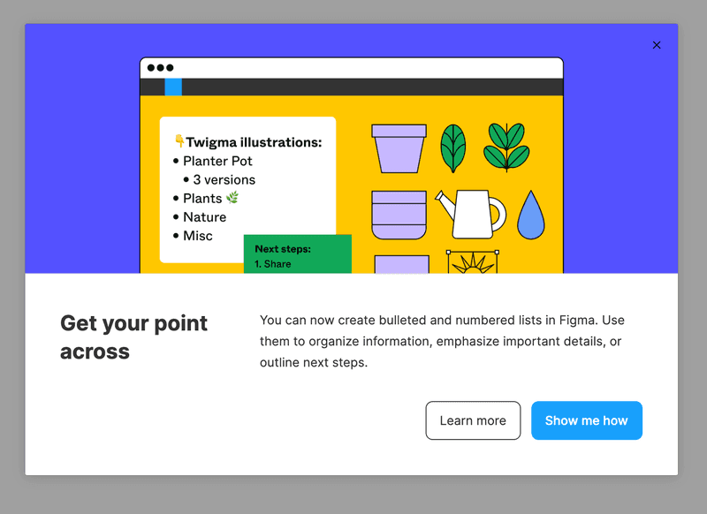

https://userpilot.medium.com/the-ultimate-guide-to-new-feature-announcement-in-saas-ec99ec0311ac

***Before you submit your thread, put your name in the subject line.***

**Assignment Requirements and Grading:**

1. An initial post of approximately 250 words is due by **Thursday, 11:59 p.m. CST**.
2. For the initial post to be considered substantive, it should be at least 250 words in length and fully cover the topics being presented. Single-sentence definitions or responses will not be awarded points.
3. Submit your post by clicking on the **Assignment Link** above, then **Create Thread**. You must create a thread in order to view your peers' posts. Tip: Create your post in a Word document and then copy and paste your work into the thread.
4. A minimum of three (3) responses, **to the original threads of other students**, of 100-200 words each are due by **Sunday, 11:59 p.m., CST**.
5. To view the rubric grading criteria, click on the following link: [Discussion Board Grading Rubric](https://content.bellevue.edu/cst/csd/rubricdbv3.pdf).

**(50 points)**

Colton, you did an excellent job on your post for this module and I really enjoyed reading it and viewing your visual embellishments. You are correct that cultural background shapes how people perceive and interact with the world. Even if someone’s main culture seems similar to another, it does not mean they will view something the same way because other subcultures still influence them. I enjoyed the visual embellishments for both topics. I am always surprised how much web and application use can rely on muscle memory. Sometimes, when I think about doing a task I do daily when I think of how to do it, I forget how to proceed.

Jessica, you did a great job embellishing how culture affects how people think, and attention is selective. Our cultural norms and values shape how we process information, interpret symbols, and interact with designs. This means we need to think of more people than just our target demographics when creating a user interface design. It is best to understand how elements will be received in different areas of the world. What do you think about McDonald's choice to change site designs based on locations? I think it is a great idea, but I wonder if it may not be sustainable for smaller businesses.

Samir, you did a thorough job of embellishing this module. It was a reassuring reminder that creativity comes through combining, exploring, transforming, and challenging. Often, I can get into a creative rut, feeling stuck and as if I am not creative. Knowing this is a good way of getting out of this rut and remembering that creativity comes in different forms. I liked the analogy of building Legos because it fits its point. I love it when I enter into a flow state. I feel so accomplished afterward, and it is so rewarding! I try to take full advantage whenever I have a chance.